# Supplemental material for the paper:

# Tightness and Consensus of Italian Political Attitudes

This file contains all additional materials for the paper. Data and code are made available at: <https://github.com/arturobertero/IPBS_ggm>

## 1. Descriptives

Table 1 shows the descriptives of each attitudinal variable. Table 2 below reports the number of respondents for each category of the stratificational measures (political interest, education) and of the moderating variable (self-reported vote choice)

*Table 1: Descriptives*

|  |  |  |  |  |  |
| --- | --- | --- | --- | --- | --- |
|  | | | | | |
| Variable | N | Mean | St. Dev. | Min | Max |
|  | | | | | |
| L_R | 1,149 | 4.560 | 3.010 | 0 | 10 |
| PTV_PD | 1,149 | 3.803 | 3.455 | 0 | 10 |
| PTV_FI | 1,149 | 1.984 | 2.889 | 0 | 10 |
| PTV_L | 1,149 | 2.208 | 3.162 | 0 | 10 |
| PTV_M5S | 1,149 | 2.793 | 3.378 | 0 | 10 |
| PTV_FDI | 1,149 | 3.036 | 3.753 | 0 | 10 |
| adopt | 1,149 | 2.777 | 1.127 | 1 | 4 |
| abort | 1,149 | 3.293 | 0.940 | 1 | 4 |
| eutha | 1,149 | 3.298 | 0.924 | 1 | 4 |
| marria | 1,149 | 3.061 | 1.042 | 1 | 4 |
| redis | 1,149 | 4.386 | 1.610 | 1 | 6 |
| flat_t | 1,149 | 2.648 | 1.774 | 1 | 6 |
| m_wage | 1,149 | 4.788 | 1.449 | 1 | 6 |
| cit_in | 1,149 | 4.074 | 1.662 | 1 | 6 |
| globa | 1,149 | 3.213 | 1.552 | 1 | 6 |
| immig | 1,149 | 4.223 | 1.810 | 1 | 6 |
| big_go | 1,149 | 4.681 | 1.598 | 1 | 7 |
| pub_pri | 1,149 | 3.323 | 1.829 | 1 | 7 |
| ukrai | 1,149 | 2.613 | 1.089 | 1 | 4 |
| age | 1,149 | 53.326 | 15.528 | 19 | 91 |
| pol_int | 1,149 | 2.923 | 0.756 | 1 | 4 |
|  |  |  |  |  |  |

*Table 2: Stratificational varibles*

|  |  |
| --- | --- |
| Variable | N |
| **Political interest** |  |
| *Low* | 49 |
| *Medium low* | 228 |
| *Medium high* | 634 |
| *High* | 238 |
| **Education** |  |
| *Less than university* | 706 |
| *Degree or more* | 443 |
| **Vote choice** |  |
| *Right-wing coalition* | 359 |
| *Left-wing coalition* | 450 |
| *5SM* | 193 |
| *Other* | 136 |
|  |  |

## 2. Estimated networks

This Section shows the comparison of correlational and mgm networks estimated on the different sample partitions. Figure 1 portrays correlational networks; Figure 2 shows the mgms.

*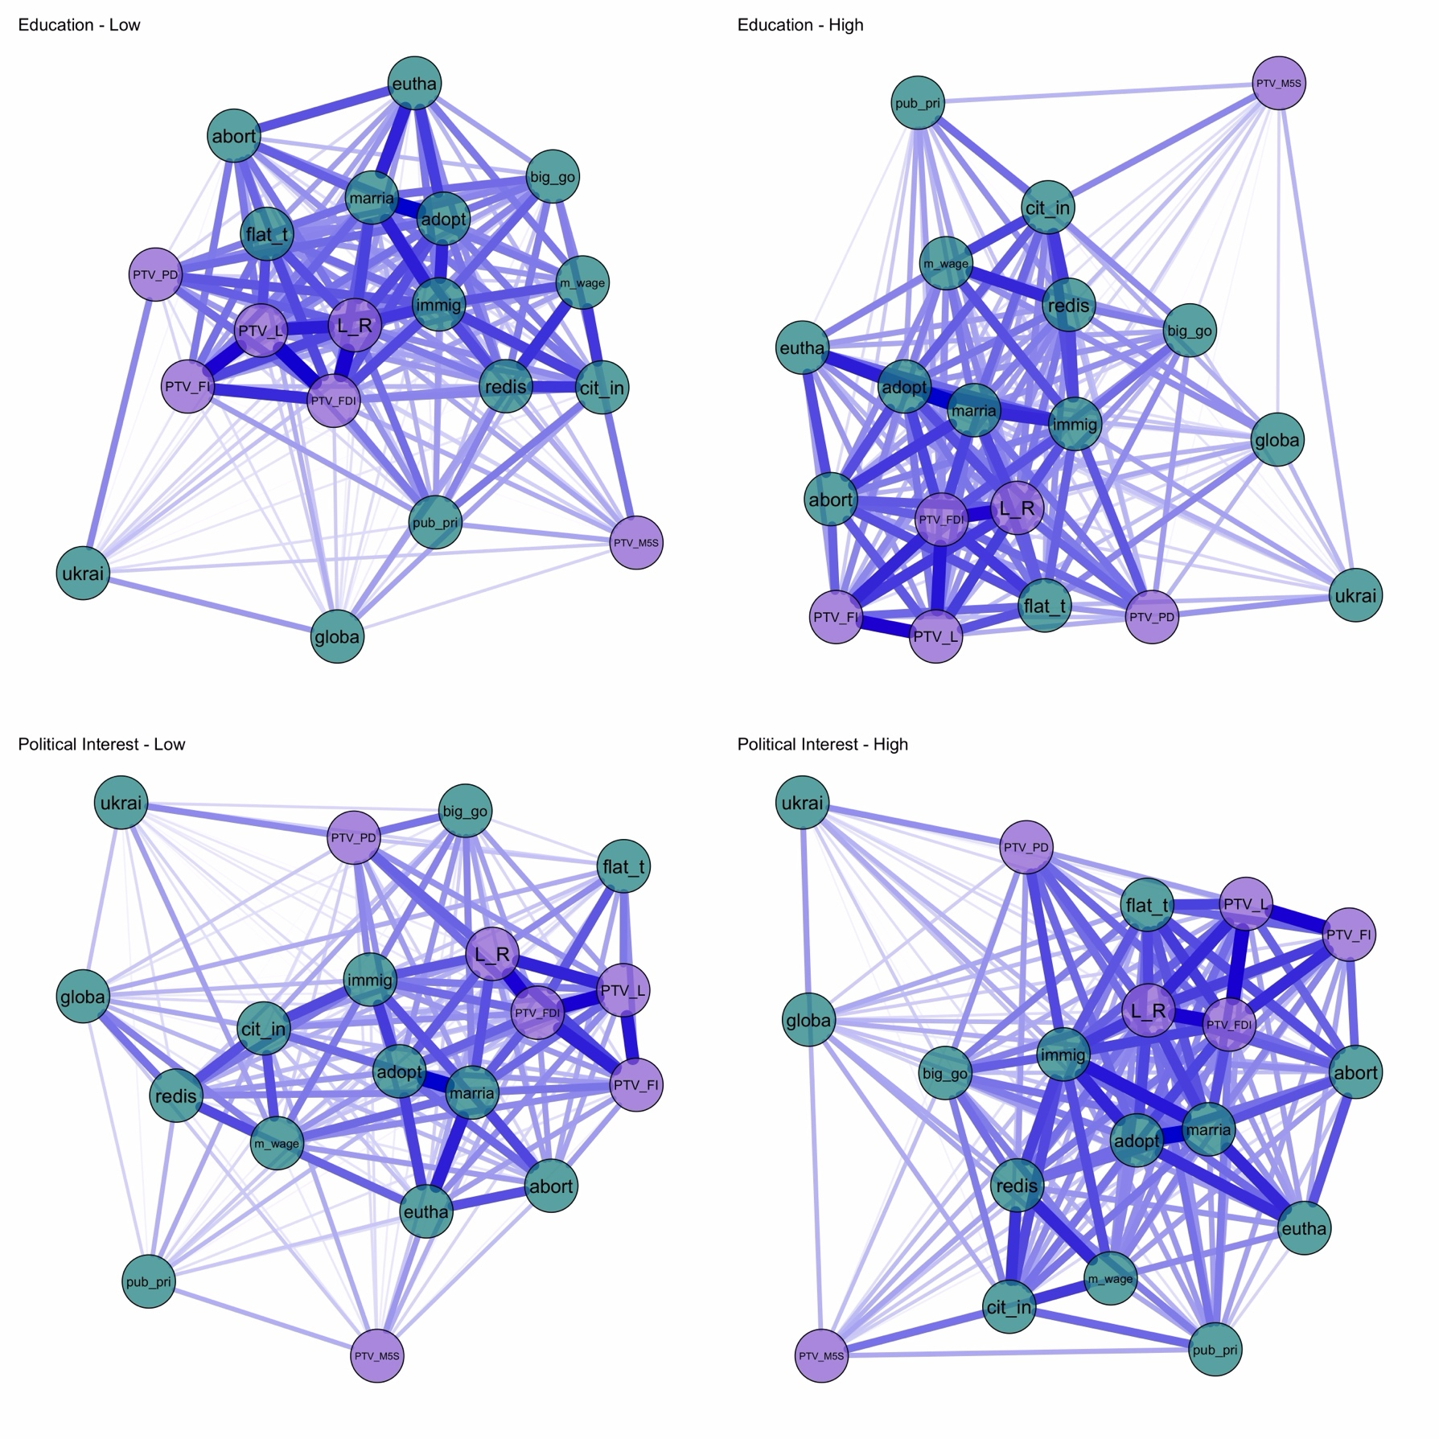Figure 1: Correlational networks by levels of political interests and education*

*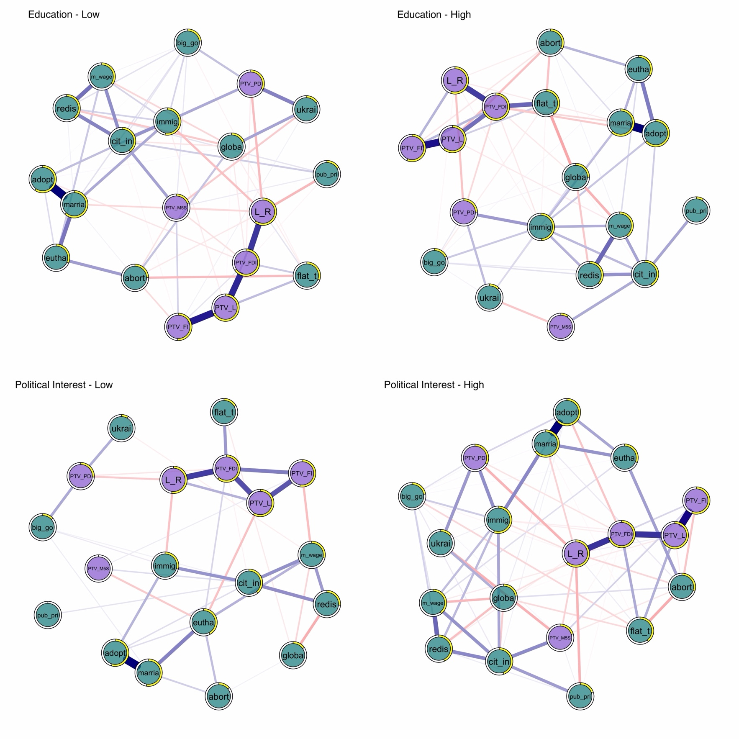Figure 2: mgm networks by levels of political interests and education*

## 2. Robustness checks on H1 and H2

Figure 3 shows that mean constraint and political interest are stably related only for correlational networks. In the top panel, political interest is recoded as (I) low + medium-low; (II) medium-high; (III) high. In the bottom panel, I contrast (I) low + medium-low; (II) medium-high + high.

Table 3 provides numeric values behind the lollipop plot of Figure 4 of the Article.

Figure 4 shows the significant moderation coefficients obtained when fitting two moderated network models with political interest and education specified as the moderators.

*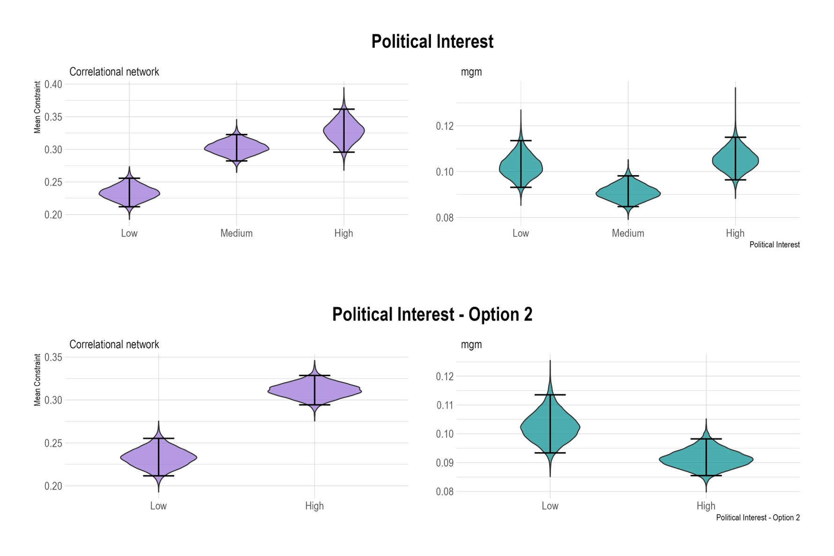Figure 3: Robustness tests of H1*

*Table 3: Node-wise R2 values of the central panel of Figure 4 of the Article*

|  |  |  |  |  |
| --- | --- | --- | --- | --- |
| *Variable* | *pol_int_low* | *pol_int_high* | *educ_low* | *educ_high* |
| L_R | 0.52 | 0.62 | 0.60 | 0.55 |
| PTV_PD | 0.26 | 0.33 | 0.32 | 0.25 |
| PTV_FI | 0.53 | 0.56 | 0.51 | 0.56 |
| PTV_L | 0.58 | 0.67 | 0.68 | 0.61 |
| PTV_M5S | 0.00 | 0.20 | 0.19 | 0.09 |
| PTV_FDI | 0.61 | 0.70 | 0.65 | 0.70 |
| adopt | 0.55 | 0.63 | 0.60 | 0.64 |
| abort | 0.14 | 0.30 | 0.25 | 0.33 |
| eutha | 0.42 | 0.31 | 0.31 | 0.33 |
| marria | 0.53 | 0.64 | 0.62 | 0.62 |
| redis | 0.26 | 0.43 | 0.39 | 0.37 |
| flat_t | 0.17 | 0.40 | 0.30 | 0.40 |
| m_wage | 0.29 | 0.39 | 0.35 | 0.40 |
| cit_in | 0.39 | 0.44 | 0.40 | 0.42 |
| globa | 0.15 | 0.23 | 0.19 | 0.25 |
| immig | 0.29 | 0.55 | 0.53 | 0.49 |
| big_go | 0.13 | 0.22 | 0.23 | 0.18 |
| pub_pri | 0.00 | 0.20 | 0.17 | 0.09 |
| ukrai | 0.08 | 0.14 | 0.15 | 0.13 |

*Figure 4: significant moderation coefficients for education and political interest*

